**An Autumn Contemplative Walk**

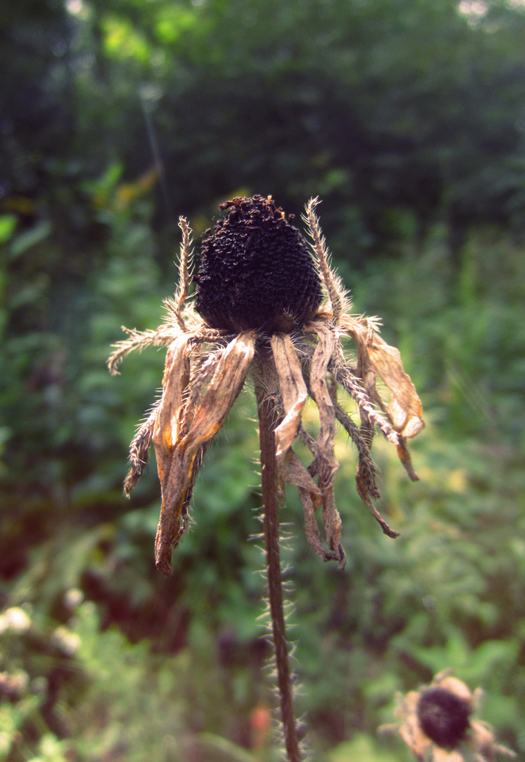“One of my favorite moments from (autumn) last year was going to Brigid’s garden… where we put the garden to sleep. “You can rest now” were the words we uttered to the trees and to ourselves.” (Christine Valters Paintner)

You are invited to take a contemplative walk: a time to wander in the world prayerfully and with reverence, opening to the gifts being revealed.

Remember that a contemplative walk is one without a particular destination in mind, only an invitation to connect to your heart, breathe deeply, and  
listen to how things are unfolding before you.

What is shimmering in the world around you, beckoning you to pay closer attention? Might you linger with the last of the leaves being blown from the trees? Or behold the signs of winter’s slow emergence?

Allow some time to be present to the world and to really notice the early signs of winter, the dark season in your neighborhood. When you slow yourself down, what are the signs you discover? What new insights burst forth in this lavish attentiveness to the world’s descent into rest?

Make sure to pause each time you feel something beckoning.

Listen closely to what this moment might have to reveal to you about your soul’s own desire for rest and spaciousness.

adapted from: Christine Valters Paintner, “Sacred Seasons: Celtic Wheel of the Year”